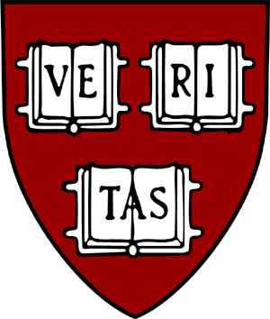 | KOREA INSTITUTE  HARVARD UNIVERSITY • 1730 Cambridge Street • CGIS South, Room S228 • Cambridge, MA 02138 • Tel: 617-496-2141  Fax: 617-496-8083 • E-Mail: <koreainstitute@gmail.com> • HomePage: <http://korea.fas.harvard.edu>

Summer Grants from the Korea Institute – Language Instructor Reference

Student’s Full Name:

Instructor’s Full Name:

Most recent course in which you have taught the applicant (course name and date of semester):

The above student has applied for a grant from the Korea Institute (KI) to pursue summer research or language study in Korea. Please rate the applicant on a 1-5 scale (5 being the highest), underlining and bolding the appropriate score in each of the categories below. In each case, please rate the applicant at his/her current level (or at the level at which you have most recently taught him/her) and relative to the other students in the course in which you most recently taught him/her.

Classroom performance (grades):

1 2 3 4 5

Proficiency skills in the target language:

Speaking 1 2 3 4 5

Listening 1 2 3 4 5

Reading 1 2 3 4 5

Writing 1 2 3 4 5

Likelihood that student will make good use of time abroad to advance language skills (including evidence of planning in choosing appropriate study abroad program):

1 2 3 4 5

Cultural sensitivity (interpersonal skills; likelihood of successful assimilation in target culture):

1 2 3 4 5

Level of emotional maturity and ability to deal with stress:

1 2 3 4 5

Please comment below (or on a separate sheet) on any other factors, including special circumstances that you feel should be taken into account in judging the student's application for a summer research or language study grant at the KI:

Please also provide your level of support and the necessity for the language program that the student is proposing.

Language Instructor’s Signature:
(or type name in lieu of a signature)

Date:

Please complete your evaluation in Word and save it as PDF for submission to CARAT.
AY21-22 Form

Please note that this form is used for both undergraduate and graduate grants
at the Korea Institute.

